عنوان مقاله | Sinus lift surgery; before, during the procedure, aftercare
برای | Missionimplantcenter.com
کد مقاله | 44738

کلمات هدف
Sinus lift surgery, Sinus lift procedure, Sinus lift cost, Sinus lift instruments, Sinus lift recovery, Sinus lift complications, dental Sinus lift, internal Sinus lift, indirect Sinus lift, direct Sinus lift.

اهمیت | کم | متوسط | زیاد | خیلی زیاد
رقابت | کم | متوسط | زیاد | خیلی زیاد

توصیف
Why is Sinus lift done? How is the procedure of Sinus lift? What are the aftercare tips of Sinus lift? What should I do before Sinus lift? Sinus lift recovery time.

منابع
https://www.dentaly.org/us/teeth-implants-cost/sinus-lift/
https://blog.zentist.io/the-patients-guide-to-a-sinus-lift-procedure-ab0c46bd8570
https://www.lvoralsurgery.com/dental-implants/sinus-lift-aftercare/
https://ssatyler.com/instructions/post-operative-instructions-bone-grafting-sinus-lift/
https://www.arizonadentalspecialists.com/sinus-lift-benefits-cost-risks-recovery/
https://nearsay.com/c/599371/501835/3-advantages-of-a-sinus-lift-procedure

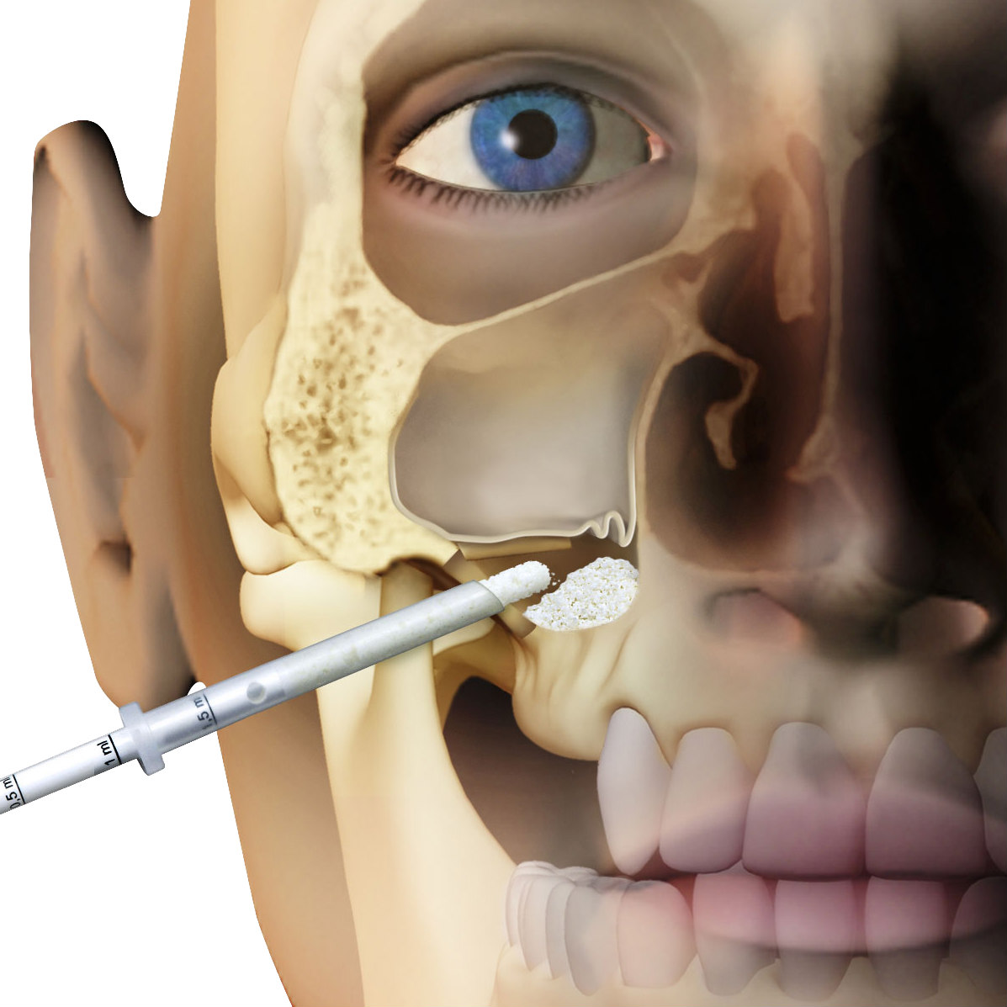Being told you need a sinus lift before getting tooth implants may seem daunting, but there is no need to worry. It’s a relatively common surgical procedure that can make it possible for you to have implants(link with dental implants vs dentures) even after suffering bone loss. It’s a surgical procedure which grafts bone to the upper jaw at the position of the molar and premolar teeth. The maxillary sinus membrane is lifted upwards to make space for the additional bone.
The sinus system has several parts but it’s the maxillary sinuses which sit closest to our teeth. You might sometimes get a toothache when you have congestion or a bad cold – this is because the pressure on the sinuses transfers to the tooth roots in the upper jaw.
The technical name for this procedure is a “maxillary sinus floor augmentation”, but you may also hear the terms “sinus augmentation” and “sinus graft” used. A specially-trained dental clinician, periodontist or oral surgeon carries out the surgery.

Why might you need this procedure? [h2]

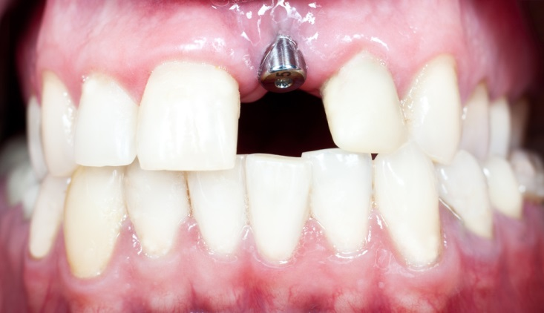
A sinus augmentation is usually performed when a patient has insufficient bone in their upper jaw to support a dental implant. Dental implants fuse with the jaw bone in a natural process called osseointegration, but this relies on there being a certain amount of bone present.
You may need sinus lift surgery before getting implants if:
- your jaw bone has previously been damaged, for example from trauma or a difficult extraction;
- a cyst or tumor has been removed from the area;
- you have suffered bone loss as a result of periodontitis;
- your bone has receded because of tooth loss (the socket can lose 40-60% of its bone structure within the first three years);
- you naturally have a large sinus cavity or thin jaw bone.
Not everyone who gets molar or premolar teeth implants will need this surgery. However, it’s a fairly common procedure.

Preparation [h2]
To begin with, your dental surgeon will conduct a consultation to discuss your needs. As part of this, they will take dental x-rays, and perhaps CT scans, to assess the current condition of your jaw and ascertain whether you are a suitable candidate for a sinus procedure.
The grafted bone can be sourced from a number of places:
- Your own body (either from another part of your mouth or another bone – often in the hip or leg)
- Another human (people may donate their bone tissue when they die)
- Cow bone
- A synthetic material such as hydroxyapatite
All of these materials are safe and are processed to ensure they are free from disease.

Surgical procedure [h2]

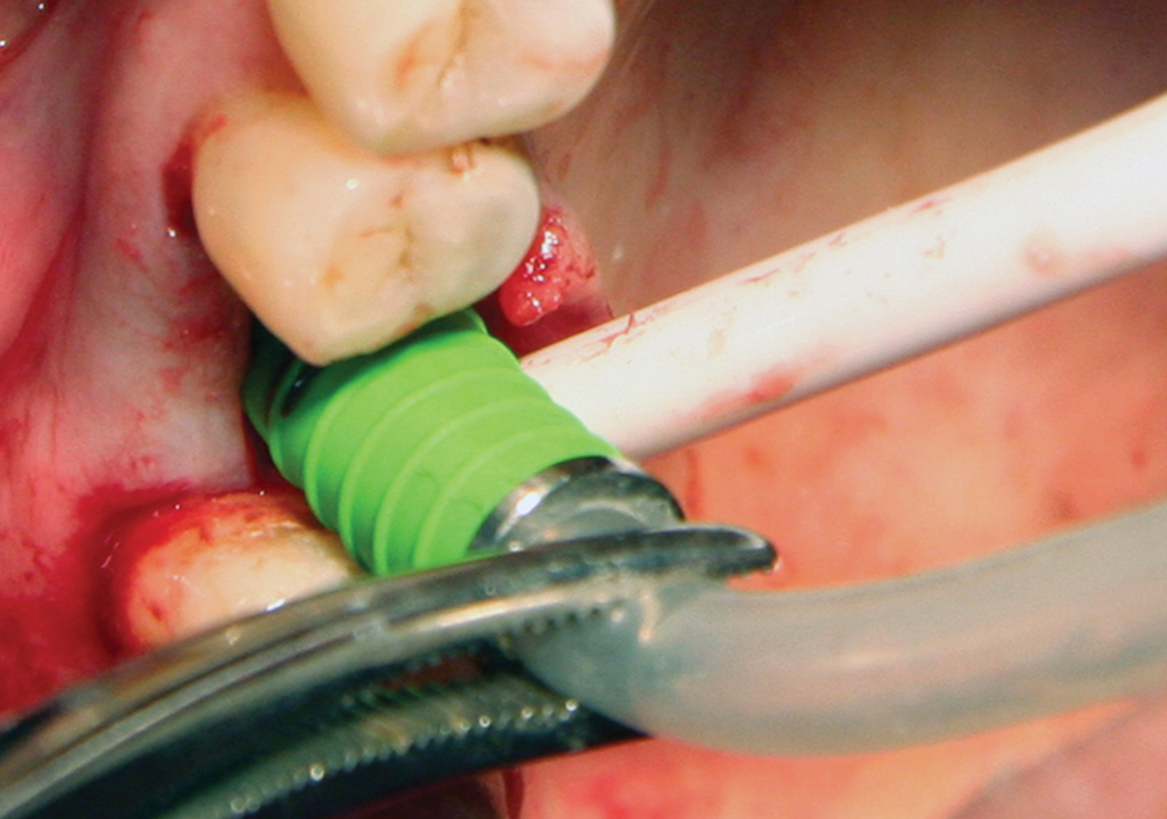
There are various ways to carry out sinus graft surgery. They all begin with making an incision in the gum to expose the bone underneath. Most commonly, the dentist cuts a small “window” into the bone and pushes it up to reveal the sinus cavity. The cavity membrane is lifted and the space below is filled with granules of the bone graft(link with dental bone graft) material.
Then, the gum tissue is stitched back together. The technique your dentist uses may be different, depending on your personal circumstances. Be sure to discuss this if you have any concerns.
The main risk of this surgery is the piercing or tearing of the membrane. In the rare event that this happens, it can be stitched or patched to repair it. Often the surgery can still continue as planned; in other cases, the membrane must be given time to heal before the lift takes place.

Placing the implants [h2]
Most often patients must wait 4-9 months before they receive their implants. This gives the bone a chance to fuse in its new position. The exact waiting time will depend on the type of material used.
It is possible in some cases to place the implants as part of the sinus surgery – without any waiting period. One study has shown that although this method is quite safe, the success rate is lower in patients who have a residual bone height of less than 4mm.
You might be keen to get your implants placed sooner rather than later, but your dentist will advise you on the method that is likely to achieve the best results.

3 Benefits of Sinus Lifts [h2]

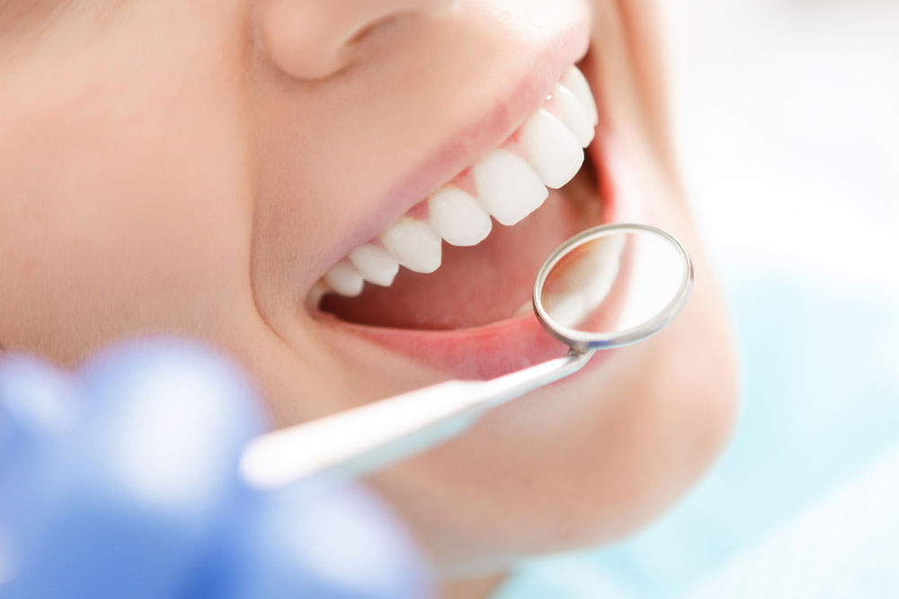

Repairs Gum Disease & Tooth Loss Damage [h3]
When gum disease goes untreated for an extensive period, the infection can cause the jawbone to deteriorate. Missing teeth will deplete essential root structures from the jawbone. Without a root to bind to, the bone can eventually be reabsorbed by the body. In both scenarios, the lost jawbone will cause the maxillary sinus cavity to shrink.
During a sinus lift, this missing bone material is replaced with a natural or synthetic graft. Once the graft is placed in the cavity, the maxillary sinus gains extra height. The graft will simultaneously stimulate natural bone production and allow you to replenish lost jaw material.

Makes Dental Implants Possible [h3]
If you want to replace a missing tooth with a dental implant, you must have enough jawbone available to support the prosthetic root structure. However, if there’s not enough bone and the sinus rests too close to the mouth, the dental implant will not take hold.
When new bone is added to the cavity during a sinus lift, oral surgeons may be able to insert the dental implant at the same time. If additional bone growth is required, most receive their implants within nine months after the initial surgery.

Reduces Risk of Sinus Damage [h3]
If the maxillary sinus wall is too thin or too close to the upper mouth, inserting an implant may injure the cavity and cause a series of complications. With a sinus lift, the cavity gains extra space, making it possible for implants to be safely inserted.

How much does a sinus lift cost? [h2]
The costs are per side and depends on how complex the work is and how much bone graft material is required. If you have already received a quote for implants, check whether this includes any preparatory work like bone grafts and sinus surgery.

Aftercare of Sinus Lift [h2]
The following information applies when upper jaw bone height or width have been lost. The graft is placed to help restore your jawbone in preparation for possible implant replacement of the missing tooth(link with replacing a single missing tooth) or teeth.
You have had a Sinus Lift Augmentation procedure in your upper jaw. This procedure regains lost bone height in the area of your first and second molar and occasionally second premolar. It is an important procedure as it allows implant placement in an area that could not be implanted otherwise because of insufficient bone height due to an enlarged sinus.
The bone that has been grafted is most commonly a combination freeze-dried bone, artificial synthetic bone and your own bone. Because of this you may have two post-surgical wounds: the donor site and the recipient site.
Do not blow your nose or sneeze holding your nose. Sneeze with your mouth open. Do not drink with straws and do not spit. Scuba diving and flying in pressurized aircraft may also increase sinus pressure and should be avoided. Decongestants such as Drixoral, Dimetapp, or Sudafed will help reduce pressure in the sinuses. You may also be given a prescription for antibiotics.

Oral Hygiene [h3]
Do not rinse or spit on the day of your surgery. This tends to disturb the blood clot, open the wound and can prolong bleeding and slow healing. You should not have a significant amount of blood in your mouth. Saliva can be swallowed, even if slightly blood tinged.
Keeping your mouth clean after surgery is essential to reduce the risk of infection. Start salt water rinses the day following your procedure. Use one-half teaspoon of salt dissolved in an 8 ounce glass of warm water and gently rinse with portions of the solution, taking five minutes to use the entire glassful. Repeat as often as you like, but at least four to five times daily and always after eating for the next five days.
Do not brush the teeth in the area of surgery for 48 hours. When brushing, be very gentle. When expectorating, also be gentle.
Doctors may prescribe an antibiotic rinse (Chlorhexadine, Periogard, Peridex) for certain procedures. This rinse should be used in the morning and at bedtime after routine mouth care. Do not eat or drink or rinse your mouth after using the medicated rinse. Using this rinse more than two times a day will cause staining of your teeth.

Smoking [h3]
Do not smoke for at least two weeks after surgery, if at all. As discussed at your consultation, smoking dramatically increases the risk of bone graft and sinus augmentation failure. Dr. Chaudhry can prescribe a Nicoderm patch if you feel you need it.

Diet [h3]
Drink plenty of fluids. Avoid hot liquids and foods. Soft foods and liquids should be consumed on the day of surgery. Keep all solid food away from the surgical site.

Pain [h3]
You should begin taking pain medication before the local anesthetic wearing off. For moderate pain, ibuprofen (Advil® or Motrin®) may be taken. Ibuprofen bought over the counter comes in 200 mg tablets: 3–4 tablets may be taken every 6–8 hours as needed for pain (no more than 3200 mg/24-hour period). For severe pain, the prescribed medication should be taken as directed. Do not take any of the above medication if you are allergic or have been instructed by your doctor not to take it. This may include patients with liver or kidney disease.

Antibiotics [h3]
Be sure to take the prescribed antibiotics as directed to help prevent infection.

Activity [h3]
Keep physical activities to a minimum immediately following surgery. If you are exercising, throbbing or bleeding may occur. If this occurs, you should discontinue exercising. Keep in mind that you are probably not taking normal nourishment. This may weaken you and further limit your ability to exercise.

Bleeding [h3]
Some bleeding or redness in the saliva is normal for 24 hours. Excessive bleeding (your mouth fills up rapidly with blood) can be controlled by biting on a gauze pad placed directly on the bleeding wound for 30 minutes. In general, use as little pressure as is needed. Change the gauze pad every 30 minutes as needed. If excessive bleeding continues, please call for further instructions. Remove gauze when it is no longer needed.

Swelling [h3]
Swelling is a normal occurrence after surgery. To minimize swelling, apply an ice bag (or a plastic bag or towel filled with ice) on the cheek in the area of surgery. Apply the ice continuously, as much as possible, for the first 48 hours. Swelling generally reaches a peak in 48–72 hours and then subsides over the next 3–5 days. If swelling begins to increase after the third post-operative day, please contact your doctor immediately.

Recovery [h2]
Immediately after your surgery you may experience swelling in the area and bleeding from your mouth or nose. You’ll probably feel uncomfortable for a few days afterwards, but most patients don’t experience major discomfort. If any bleeding continues for more than two days, or pain and swelling get worse, you should contact your dentist immediately.
There is a risk of the sinuses becoming infected, but your dentist will give you medication to protect against this. You’ll have to be careful not to sneeze or blow your nose heavily since this can move the bone graft material or dislodge your stitches. If you are prone to allergies, your surgery will probably be scheduled for a time of year when these won’t flare up.
After 7-10 days you’ll return to your dentist so he can check the progress of your healing and remove your stitches, if they haven’t dissolved by themselves. You’ll have several more visits during the healing process to check everything is going as planned.

